
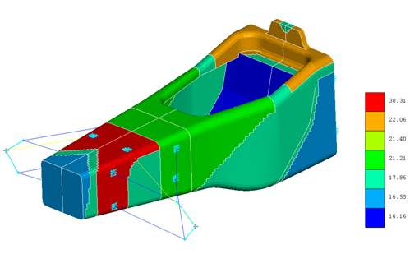
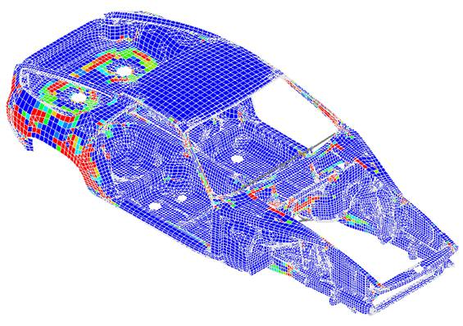
Press Release 3/2007
DYNAmore GmbH
Gesellschaft für FEM-
Ingenieurdienstleistungen

DYNAmore distributes and supports
VR&D optimization software products

Stuttgart, August 28, 2007 - The Vanderplaats Research & Development Inc. (VR&D) has announced a cooperation with LSTC and its German distributor DYNAmore GmbH. VR&D is a renowned leader in the field of optimization software. Their software packages GENESIS and VisualDoc are known for excellence in topology and shape optimization and parametric optimization, respectively. In addition to automotive companies such as General Motors, Ford, and Toyota, VR&D optimization software is used by a number of large and known aerospace companies and other industrial analysts.

DYNAmore GmbH is proud to announce that its newly founded “Optimization Competence Center” based in Ingolstadt will support and distribute VR&D's complete software portfolio to customers in Germany, Austria, Switzerland, Spain, Holland, Belgium and Italy. Furthermore, a technological exchange between LSTC, the developer of LS-DYNA and LS-OPT, and VR&D has been agreed upon.

Dr. Heiner Müllerschön, head of the “Optimization Competence Center” at DYNAmore, says: “In recent years, the use of LS-OPT has increased much. LS-OPT uses optimization methods that are employed to highly nonlinear problems and are widely used in the optimization of crash simulations with LS-DYNA. With VR&D's GENESIS we are now able to provide our customers non-parametric shape-optimization capabilities. GENESIS furthermore offers excellence in computing and optimizing composite structures for instance for aerospace and race car applications. With VR&D's software packages GENESIS and VisualDoc we are now able to fulfill our customers' demand for a complete optimization portfolio.”
Gary Vanderplaats, founder of VR&D comments: “Our technological cooperation with LSTC goes back many years. LSTC recommended DYNAmore GmbH to us to extend our sales channels in Europe. DYNAmore's customer orientation and competence in the field of optimization and simulation have been confirmed by many DYNAmore customers worldwide. Our common goal of providing our customers with high-quality and technically-oriented solutions makes LSTC and DYNAmore a strong match. We are looking forward to a fruitful collaboration. “

For more information please contact:
DYNAmore GmbH
Industriestrasse 2, D-70565 Stuttgart
Tel. : +49 711 459600 - 0
Fax : +49 711 459600 – 29
Internet : www.dynamore.de

